


AB Bank Zambia

Monthly Report
September 2025

Contents
1. Executive Summary 2
1.1. Key Highlights: 2
1.1.1. Incident Volume & Trends: 2
1.1.2. Detection & Response Performance: 2
1.2. Incident Trends & Analysis: 3
1.3. High-Severity Incidents: 4
2. SEPtEMBER Alerts & Incidents Overview 4
2.1. Overall Volume 4
2.2. Incidents Processing 5
2.3. Mean Time To Detect (MTTD) 5
3. Incidents Highlights 6
3.1. Top Incidents by type 6
3.2. Analysis of Key Incident Trends 7
1. MSSQL Account Logon Failure (305 Incidents) 7
2. Source Stopped Sending Data: Security Events (243 Incidents) 7
3. FortiGate Successful Login (202 Incidents) 7
4. Authentication Attempt – Default Account (160 Incidents) 7
5. FortiGate UTM Alerts (139 Incidents) 7
6. FortiGate Logon Failure (65 incidents) 8
7. User Removed from a Security Enabled Group (64 Incidents) 8
8. Admin Account Logon Failure (61 Incidents) 8
9. User Added to Critical Group (51 Incidents) 8
10. SQL Service Stopped (50 Incidents) 8
3.3. High Severity 9
3.3.1. High Severity Incidents Analysis 9
1. Preview: Possible multistage attack activities detected by Fusion (2 incidents) 9
4. Cybersecurity Trends and Threats 10
4.1 Key Threats and Incidents 10
4.2 Regional Spillover and Infrastructure Risks 10
4.3 Government and Industry Response 10
5. Conclusion and Recommendations 11
5.1. Recommendations 11
5.2. Conclusion 11
Appendix – Test-server Alerts 12
Total Incidents by Severity 12
Top 10 Incidents 12
High Seveity Incidents 13

Executive Summary
This security report provides an in-depth analysis of security incidents, alerts, and operational activities managed by TeKnowledge for AB Bank Zambia during the reporting period (September 2025). The findings highlight key security trends, detection and response performance, and proactive measures taken to enhance the organization’s security posture.

Key Highlights:

Incident Volume & Trends:
A total of 1887 security incidents were generated in the production environment and 112 Security incidents in the Test Environment. All incidents were processed in Microsoft Sentinel, encompassing both manually investigated cases and automated detections.
The most prevalent security events still include Source Stopped Sending Data: Security Events, Authentication Attempt - Default Account, Admin Account Logon Failure, FortiGate UTM Alerts and
FortiGate Successful Login highlighting the efficacy of the Security on Log-Collection Status from Critical Server(s), Access Notifications on Digital assets and Prompts about Suspicious Threat attempts against the environment.

Detection & Response Performance:
Mean Time to Detect (MTTD): 3 minutes and 32 seconds, ensuring timely identification of potential threats.
Additionally, the breakdown of MTTD by severity is as follows:
High Severity: 2 minutes 48 seconds
Medium Severity: 3 minutes and 32 seconds
Informational: 3 minutes and 41 seconds
Mean Time to Resolution (MTTR): The average Mean Time to Resolution (MTTR) for this reporting period was on an average of 40 minutes. The screenshot below provides a detailed breakdown by severity.

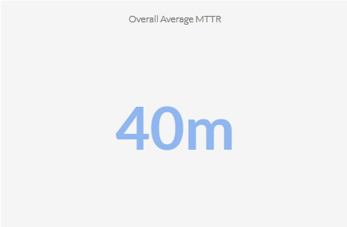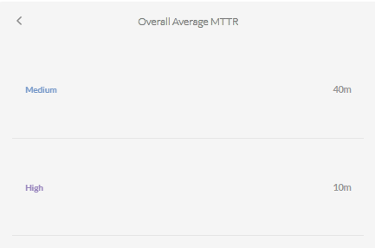

Average time to First Response: The average Time to First Response was 13 minutes. Where High Severity Incidents were responded to within 4 minute. See the screenshot below for the breakdown according to the incidents’ severity.
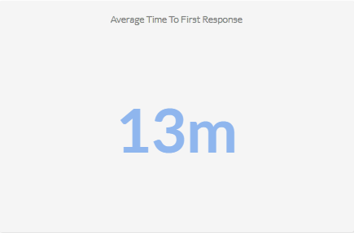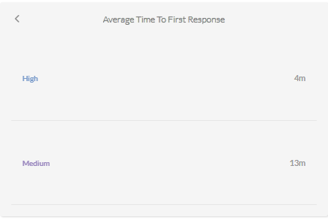

Incident Trends & Analysis:
The top recurring incident types identified in September accounted for 1052 of the total incidents. These incidents were mainly tied to Source Stopped Sending Data: Security Events, Authentication Attempt - Default Account, Admin Account Logon Failure, FortiGate UTM Alerts and
FortiGate Successful Login indicating High Service-Account Access failures, external unified Threat Management Notifications and Access to critical Assets Notification.
The most frequent alerts were related to:
- Source Stopped Sending Data: Security Events – 253
- Authentication Attempt - Default Account – 213
- Admin Account Logon Failure – 210
- FortiGate UTM Alerts – 199
- FortiGate Successful Login – 177
All these incidents were thoroughly reviewed and escalated where necessary, helping to maintain Operational stability and security to the critical Assets.

High-Severity Incidents:
A total of 10 alerts were categorized as high severity, which entails Possible multistage attack activities detected by Fusion and Non Domain Controller Active Directory Replication. The high-severity case confirmed to be carried out by an Authorized IT Administrator.

September Alerts & Incidents Overview

Overall Volume
In the month of September, a total of 1677 incidents from production environment were handled on MS Sentinel. Further breakdown in severity showed that 2 incidents were High Severity, 1627 were of Medium Severity, and 48 Informational Incidents. This volume includes manually-processed incidents and automatically-addressed incidents, through pre-configured automation protocols.

Incidents Processing
During the reporting period, TeKnowledge successfully monitored, detected, and responded to a total of 1677 security incidents within the AB Bank Zambia production environment. The SOC team processed all incidents, ensuring a comprehensive approach to threat detection and response.

Mean Time To Detect (MTTD)
The average Mean Time to Detect (MTTD) for this reporting period was 3 minutes and 35 seconds. Average Detection time for High Severity was 41 seconds, Average detection time for Medium severity was 3 minutes 33 seconds and Informational incidents were averagely detected at 4minutes 20 seconds

Incidents Highlights

Top Incidents by type
During the reporting period, TeKnowledge monitored security incidents, identifying the most prevalent issues within your environment. Below is a breakdown of the top incident types detected:
Incident Title | Sum of count
MSSQL Account Logon Failure | 305
Source Stopped Sending Data: Security Events | 243
FortiGate Successful Login | 202
Authentication Attempt - Default Account | 160
FortiGate Successful Login FortiGate UTM Alerts | 139
FortiGate Logon Failure | 65
User Removed from a Security Enabled Group | 64
Admin Account Logon Failure | 61
User Added to Critical Group | 51
SQL Service Stopped | 50
Grand Total | 1340

Analysis of Key Incident Trends
During this reporting period, TeKnowledge identified and categorized multiple security incidents within the AB Bank Zambia production environment. The breakdown below highlights key trends, notable threat patterns, and actionable recommendations to improve detection and response capabilities
- MSSQL Account Logon Failure (305 Incidents)
Description: This rule detects failed login attempts towards a Microsoft SQL Server, monitoring for specific SQL Events that indicate login failures.
Observation: All the MSSQL Account Logon failure attempt shows that the login requests were made from either internal devices or requests was made from untrusted domain. Signifying proper security measures at the database level
- Source Stopped Sending Data: Security Events (243 Incidents)
Description: This rule triggers an alert if no data is received from the SecurityEvent table, indicating that the source has stopped sending the required logs.
Observations: These was confirmed to be due to no more space on the syslog server
- FortiGate Successful Login (202 Incidents)
Description: This rule detects successful logins to FortiGate's management console by parsing the Syslog messages and extracting login details like user, source IP, and destination IP.
Observations: All FortiGate Login was confirmed to be Authorized Connection for Authorized Users.
- Authentication Attempt – Default Account (160 Incidents)
Description: This rule monitors authentication attempts using default accounts like "Administrator," "Root," or "Guest."
Feedback: Most of the failed authentication attempt was from a ‘Guest’ account on a critical Server(s). Though all attempt failed signifying a proper security measure for such vulnerability. Further measures need to be in place to disable guest accounts on critical servers, except these accounts are for live-test purposes.
- FortiGate UTM Alerts (139 Incidents)
Description: This rule detects FortiGate Unified Threat Management (UTM) alerts by parsing Syslog messages that contain UTM alert indicators and identifying relevant details like source and destination IPs.
Observation: All the Malicious requests to the critical Servers were dropped by the firewall.
- FortiGate Logon Failure (65 incidents)
Description: This rule detects failed login attempts on FortiGate devices' administrative interface. It parses the Syslog messages for failure events, while excluding specific benign scenarios.
Observations: This was observed to be due to ‘expired login credentials’ or mistyped login credentials all from within legitimate users in the Environment.
- User Removed from a Security Enabled Group (64 Incidents)
Description: This rule detects when a user account is removed from security-enabled groups by monitoring Event IDs 4729, 4733, and 4757.
Observation: All of these activities were confirmed to be carried out by authorized IT Administrators, usually for sensitive user management on critical Server systems.
- Admin Account Logon Failure (61 Incidents)
Description: This rule detects failed logon attempts for admin accounts. It monitors Event ID 4625 and filters based on failure reasons that indicate issues such as unknown user, bad password, or logon time restriction violations. The rule targets specific admin and service accounts from watchlists.
Observation: These incidents were generated mostly due to login-credential changes and wrong login credentials entered from service accounts used for important services on the Critical Servers
- User Added to Critical Group (51 Incidents)
Description: This rule detects when a user account is added to critical security groups in Active Directory by monitoring specific Event IDs (4756,4728 and 4732). It identifies the user being added and the target group to which they are added
- SQL Service Stopped (50 Incidents)
Description: This rule detects when SQL-related services are stopped on any monitored machine by parsing Event ID 7036. It focuses on services that contain "sql" in their name and tracks their state transitions to "stopped".
Review: The event occurs at times speculated for SQL Server Software updates or Machine restart.

High Severity
During the reporting period, Two high-severity incidents were recorded. The incidents were confirmed to be carried out by authorized IT Administrator.
Incident Title | Sum of count_
Preview: Possible multistage attack activities detected by Fusion | 2
Grand Total | 2

High Severity Incidents Analysis
- Preview: Possible multistage attack activities detected by Fusion (2 incidents)
Review: Microsoft Sentinel uses Fusion, a correlation engine based on scalable machine learning algorithms, to automatically detect multistage attacks by identifying combinations of anomalous behaviors and suspicious activities that are observed at various stages of the kill chain. On the basis of these discoveries, Azure Sentinel generates incidents that would otherwise be very difficult to catch. By design, these incidents are low-volume, high-fidelity, and high-severity, which is why this detection is turned ON by default.
On further investigation, it was discovered to be activities of Authorized IT Administrator

Cybersecurity Trends and Threats
In September 2025, Zambia continued to confront increasing urgency around cyber resilience, especially in financial services and regulatory policymaking. While no large-scale breach disclosures surfaced, the Bank of Zambia and legislative bodies issued warnings and proposals that underscore an elevated threat environment. The period also saw momentum in updating ICT laws and calls for stronger defense against fraud and cyber threats.

Conclusion and Recommendations

Recommendations
Optimize analytic rules to use consistent entity mapping (Account, Host, IP, Process, File hash, URL/Domain) to enable auto-grouping, speed triage, suppress non-prod noise, and improve metrics.
Review the MSSQL Server logs to identify the root causes of the Logon Failure from the accounts.
Review the Recurring Admin Account logon failure to determine if the failures were malicious sources or from a legitimate application that requires correct login credentials.
Consider integrating your WithSecure EDR solution with Microsoft Sentinel as this integration will provide centralized monitoring by consolidating endpoint and cloud workload security events into a unified dashboard, enabling more efficient incident response through streamlined investigation workflows and automation.

Conclusion
The September 2025 reporting period marked a significant step forward in the security operations of AB Bank Zambia, with TeKnowledge continuing to provide dedicated 24/7 monitoring, incident detection, and rapid response through the Microsoft Sentinel platform. A total of 1677 alerts were processed a significant increase from the previous month reflecting the need for optimization of the analytical rules in the environment.
The most detected threats included MSSQL Account Login Failure, SQL Service Stopped, Fortigate UTM Alerts and Source Stopped sending Data:Syslog, underscoring the need for sustained vigilance in identity/access management as well as operational status of critical assets.
TeKnowledge’s SOC demonstrated high operational efficiency, with the following key performance:
- Mean Time to Detect (MTTD): 3 minutes and 35 seconds
- Average Time to First Response: 9 minutes (High 1minute, Medium 9minutes)
- Average Mean Time to Resolution: 11 minutes

The high-severity incidents recorded during this period, involving Preview: Possible multistage attack activities detected by Fusion by legitimate and Authorized administrators.
As we move forward, TeKnowledge remains dedicated to strengthening your organization’s defences through:
- Continuous monitoring and rapid threat detection
- Actionable intelligence and threat containment
- Strategic improvements to rule coverage and incident handling workflows

We appreciate the trust placed in TeKnowledge to safeguard AB Bank Zambia’s digital environment and look forward to our continued partnership in building a more secure and resilient infrastructure.

Appendix – Test-server Alerts
This section documents alerts generated on test servers (non-critical) during the reporting period. These events are excluded from SLA/MTTR metrics and captured for transparency and auditability.

Total Incidents by Severity
Severity | Count of Severity
High | 1
Medium | 78
Grand Total | 79

Top 10 Incidents
Title | Sum by Title
Authentication Attempt - Default Account | 26
Admin Account Logon Failure | 14
Brute Force Attempts to Windows Servers | 8
ABBANK\rm_kangwa.mwaba Has Logged Into S-ABZ-myMBS-T03.abbank.co.zm | 5
ABBANK\rm_mwenya.kaunda Has Logged Into S-ABZ-myMBS-T01.abbank.co.zm | 3
ABBANK\rm_miyoba.sikabbubba Has Logged Into S-ABZ-myMBS-T01.abbank.co.zm | 3
ABBANK\andrey.botrasov Has Logged Into S-ABZ-WALLET-T1.abbank.co.zm | 2
User Added to Critical Group | 2
ABBANK\rm_kangwa.mwaba Has Logged Into S-ABZ-WALLET-T1.abbank.co.zm | 2
ABBANK\rm_dalitso.jeke Has Logged Into S-ABZ-myMBS-T01.abbank.co.zm | 2
ABBANK\rm_dalitso.jeke Has Logged Into S-ABZ-WALLET-T4.abbank.co.zm | 2
Grand Total | 69

High Seveity Incidents
Title | Count of Title
Preview: Possible multistage attack activities detected by Fusion | 1
Grand Total | 1

